INVASIVE WEED MAPPING FORM
Species (common, Latin) name: |  |  |  | Purple Loosestrife (Lythrum salicaria)
Observation date: |  |  |  |  | Observation time(s):
 |  |  |  |  | 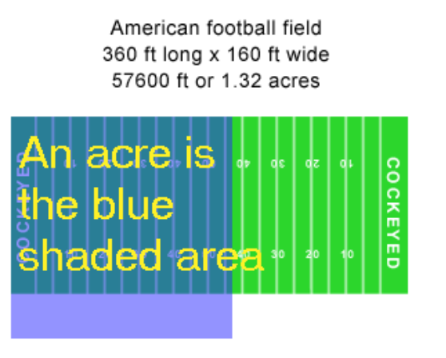
Observation team members:
 | Contact email address(es):
 | Contact telephone number(s):
Area searched:
 | Town - |  |  | Map section - |  | Main road(s) -
 | Description of area search (e.g. west of Newbury Road to east of High Street):
Surrounding land use:
Landowner(s) contacted:
 | Name |  |  | Property Address |  |  |  | Telephone
Was the area thoroughly searched? |  |  |  |  | ___yes | ___no | ___uncertain
 | If uncertain, explain:
Comments:

DATA FOR EACH PURPLE LOOSESTRIFE PATCH FOUND
 |  |  |  |  |  |  |  | page ____ of ____
1. Assign a unique ID# for the patch, starting with your initials. Label photos with ID if taken.
2. Description of location: Town, road intersection/other landmarks; GPS coordinates if available
3. Any evidence of beetles/beetle damage? Yes/no. Please note NA if you did not check.
Describe: Beetles/larva/eggs present, holes in leaves, windowpane pattern in leaves.
4. Estimate patch size: A= A few square yards,
B= Less than an acre, but more than a few square yards, C= More than an acre (football field)
5. Estimated % cover of wetland infested with purple loosestrife.
 | A = <25%, B = 25-50%, C = 50-75% or D = 75-100%
6. Any other invasives present (Phragmites, Perennial Pepperweed, Japanese Knotweed, etc.)
7. Percent confidence that the patch is purple loosestrife?
1  Patch ID | 2. Location Description: Town, Road intersection/ GPS Coordinates |  | 3. Evidence of Beetles/ damage? |  | 4. Patch Size | 5. Density | 6. Other invasives |  | 7.  ID % Confidence

